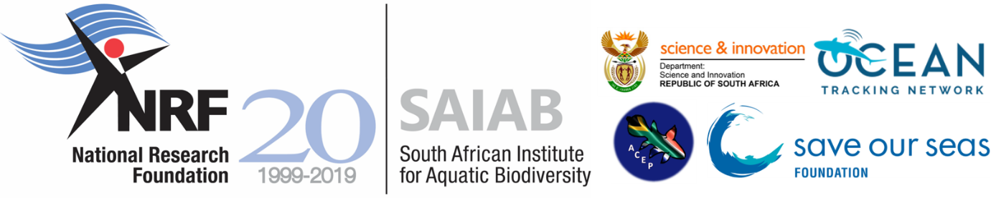

South African Institute for Aquatic Biodiversity
Summer School 2019

As a National Research Facility of the National Research Foundation (NRF), the South African Institute for Aquatic Biodiversity (SAIAB) is an agency of government with responsibility to ensure that emerging scientists are exposed to the best the nation has to offer – this includes experiential training and insight into scientific research as well as an appreciation of the important role effective communication of research plays in developing public awareness of science.

The South African Institute for Aquatic Biodiversity (SAIAB) is running a Summer School. Undergraduate (2nd and 3rd year students) and postgraduate (Honours) students, with a view of continuing to post-graduate levels in the field of Aquatic Biodiversity, are invited to attend the Summer School to be held from 02 – 05 December 2019 in Port Alfred, Eastern Cape. The course introduces participants to fieldwork in estuarine and marine environments, acoustic telemetry and baited remote underwater stereo-video systems, as well as data analysis associated with both methods.

Numbers are limited (maximum of 10 applicants). Course costs will be covered, including transport, accommodation, field trip and food costs.

For further information contact:
Matt Parkinson
Ph: 046 603 5822
Fax: 046 622 2403
Email: m.parkinson@saiab.ac.za

http://www.saiab.ac.za

Applications close on 01 November 2019.

SAIAB reserves the right not to hold the Summer School in 2019 if insufficient applications are received.
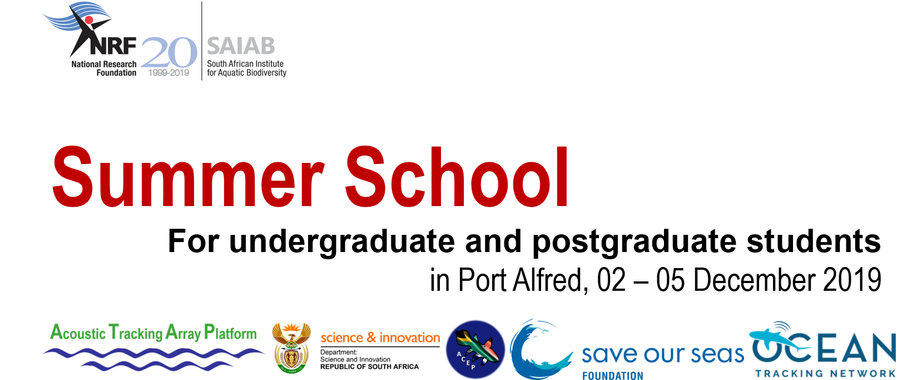

Fill in the form and submit your application no later than the 01 November 2019 to Matt Parkinson at m.parkinson@saiab.ac.za. Please remember to include a copy of your ID.
Name and surname:
Contact number:
Email address:
ID Number:
University registered with:
Year of study (e.g. 3rd, Honours):
Why would you like to attend the Summer School? (max. 200 words)

