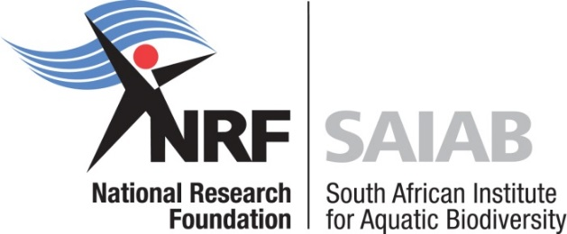

South African Institute for Aquatic Biodiversity
Summer School 2023

As a National Facility of the National Research Foundation (NRF), the South African Institute for Aquatic Biodiversity (SAIAB) is an agency of government with a responsibility to ensure that emerging scientists are exposed to the best the nation has to offer – this includes experiential training and insight into scientific research as well as an appreciation of the important role effective communication of research plays in developing public awareness of science.

SAIAB is proud to be running a Summer School again this year. Undergraduate (2nd and 3rd year students) and postgraduate (Honours) students, with a view of continuing to post-graduate levels in the field of Aquatic Biodiversity, are invited to attend the Summer School to be held from the 4th – 8th December 2023 in Port Alfred, Eastern Cape. The course introduces participants to fieldwork in estuarine and marine environments, acoustic telemetry and baited remote underwater stereo-video systems, as well as data analysis associated with both methods.

Numbers are limited (maximum of 10 attendees). Course costs will be covered, including transport, accommodation, field trip and food costs.

For further information, contact:
Danielle Julius
Email: d.julius@saiab.nrf.ac.za

http://www.saiab.ac.za

Applications close at 17:00 on 13 October 2023. No late applications will be considered.

SAIAB reserves the right not to hold the Summer School in 2023 if insufficient applications are received.
Summer school for undergraduate and postgraduate students
in Port Alfred, 4 – 8 December 2023

Fill in the form and submit your application no later than 17:00 on 13 October 2023 to Danielle Julius at d.julius@saiab.nrf.ac.za. Please remember to include a copy of your ID.
Name and surname:
Contact number:
Email address:
ID Number:
University registered with:
Year of study (e.g. 3rd, 4th /Hons):
Why would you like to attend the Summer School? (max. 200 words)
This form is used to collect personal information used to review eligibility for a summer school hosted by SAIAB. The information collected will be used solely for this purpose and will be subject to the Protection of Personal Information Act (POPIA). By submitting this form, you consent to the collection and use of your personal information for the application review. Details will be destroyed once this program concludes.

