
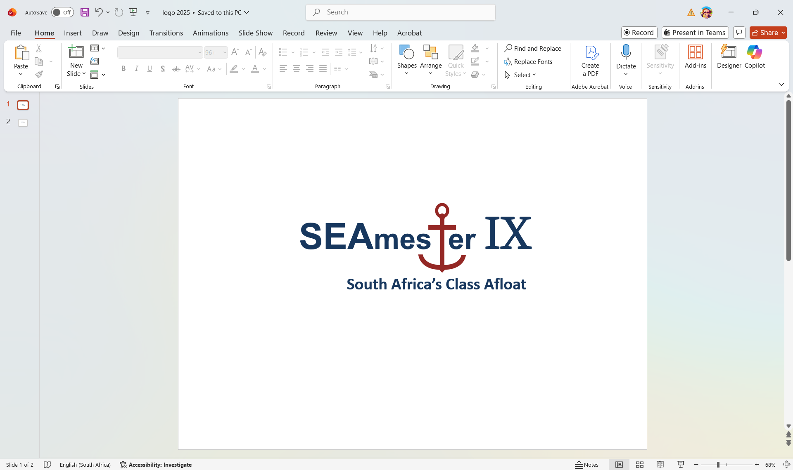

1st – 10th June 2026
Lecturer support for the SEAmester/Coast 2 Current programmes
EXPRESSION OF INTEREST - Deadline Thursday 19th March 2026
To be returned to Isabelle.Ansorge@uct.ac.za as a single PDF form

Personal details

Title
First name
Last name
Gender | - Female  - Male
Date of birth
Contact Number
Email Address
Country of citizenship
Passport number
ATTACH SCAN TO THIS FORM IF AVAILABLE – NB: PASSPORT DETAILS CAN BE PROVIDED LATER IF YOU DO NOT HAVE.
Expiry Date
South African ID (if available)
Email
Institute
Department
Field of Research/Expertise
Clothing size | - S  - M  - L  - XL  - XXL  - XXXL
Name of contact person in case of any emergency
Airport – PLEASE TICK THE AIRPORT THAT YOU WILL NEED TO FLY FROM TO CAPE TOWN | - PORT ELIZABETH  - EAST LONDON  - BLOEMFONTEIN  - DURBAN  - OR TAMBO - JOHANNESBURG
Email
Telephone/Mobile number
Short Biography and Photo
Which Lecturing component are you interested in joining? | - TOOLS OF THE TRADE – MUST INCLUDE 6 DAYS WORTH OF A 3 HOUR LONG DECK-BASED PRACTICAL (TO BE REPEATED EVERYDAY WITH A NEW GROUP OF STUDENTS IN YOUR CLASS)  - OCEANS IN A CHANGING CLIMATE - MUST INCLUDE 6 DAYS WORTH OF A 3 HOUR LONG DECK-BASED PRACTICAL (TO BE REPEATED EVERYDAY WITH A NEW GROUP OF STUDENTS IN YOUR CLASS)  - „SEAs“ THE DAY – ART AND PERSONAL GROWTH STREAM  - EVENING LECTURE  - Additional – provide example i.e. SEAmester Sunday talks

Information on Lectures and their relevant practical sessions.

PLEASE NOTE that all LECTURES IN TOOLS AND OCEANS MUST INCLUDE A 3 HOUR PRACTICAL COMPONENT THAT IS DECK-BASED that allows students to gain hands on experience.

i.e. a lecture on benthic ecosystems might plan for students to sort through various sediments i.e. mud, shell, sand etc.. Equipment that could be requested for this could be benthic grab, laboratory samples of different sediment, microscopes, petri dishes, tweezers etc..

PLEASE NOTE: STUDENTS RANGE FROM HONOURS TO PHD AND ACROSS ALL UNIVERSITIES. SOME HAVE BEEN EXPOSED TO OCEANOGRAPHY/MARINE BIOLOGY OTHERS ARE RELATIVELY NEW TO THE SUBJECT – PLEASE CONSIDER THIS WHEN WRITING UP YOUR LECTURES.

Please provide a title for each lecture that you plan to give during the voyage.  EACH LECTURE IS 50 MIN AND YOU SHOULD PLAN FOR A MAX 2 LECTURES AND A 3 HOUR PRACTICAL  AS A TOOLS OF THE TRADE OR OCEANS IN A CHANGING CLIMATE LECTURER, BY SIGNING, I UNDERSTAND THAT MY APPLICATION MUST INCLUDE A 3 HOUR BASED PRACTICAL THAT I WILL OVERSEE AND REPEAT DAILY FOR THE ENTIRE 6 DAY TEACHING PROGRAMME – UNLESS A SPECIAL ARRANGEMENT HAS BEEN OFFICIALLY REQUESTED (I.E. SEAL DISSECTIONS) | TITLES :  LECTURE 1 – 50 minutes max  LECTURE 2 – 50 minutes max  Title of Deck-based practical  SIGNATURE NEEDED HERE
Please provide information on the practical linked to the lecture i.e. all lectures must have a practical component that will be completed by the students during their deck training.

What equipment will you be providing for your practical sessions?

How will you manage your practical if bad weather shuts down all overside operations? i.e. can you collect samples from the seawater supply?

Can you bring spare samples from your institute?

What equipment is required from the vessel? | - Nothing  - Yes – please provide detail
IN ADDITION:

SEAmester students will work in groups of 4 with a lecturer/mentor on a single project throughout the cruise.

In this box please provide a title for a suitable project that links into both the deck and class work that you will have given.

SEAmester South Africa’s Class Afloat – Lecturer Declaration

I, the undersigned, acknowledge and accept my responsibilities as a lecturer on the SEAmester Program. I understand that SEAmester upholds a long-standing reputation for excellence in delivering high-quality, intensive, engaging academic content and hands-on training.

By signing this declaration, I commit to:
- Delivering well-prepared, high-quality lectures aligned with SEAmester’s standards.
- Actively guiding and mentoring students throughout the voyage.
- Dedicating my full time and expertise to the program without distraction.
- Contributing to a productive and focused learning environment.

I understand that SEAmester is an intensive academic experience, and I pledge to uphold its reputation by providing my full commitment for the duration of the voyage.

Signature: _____________________

Date: _____________________

