
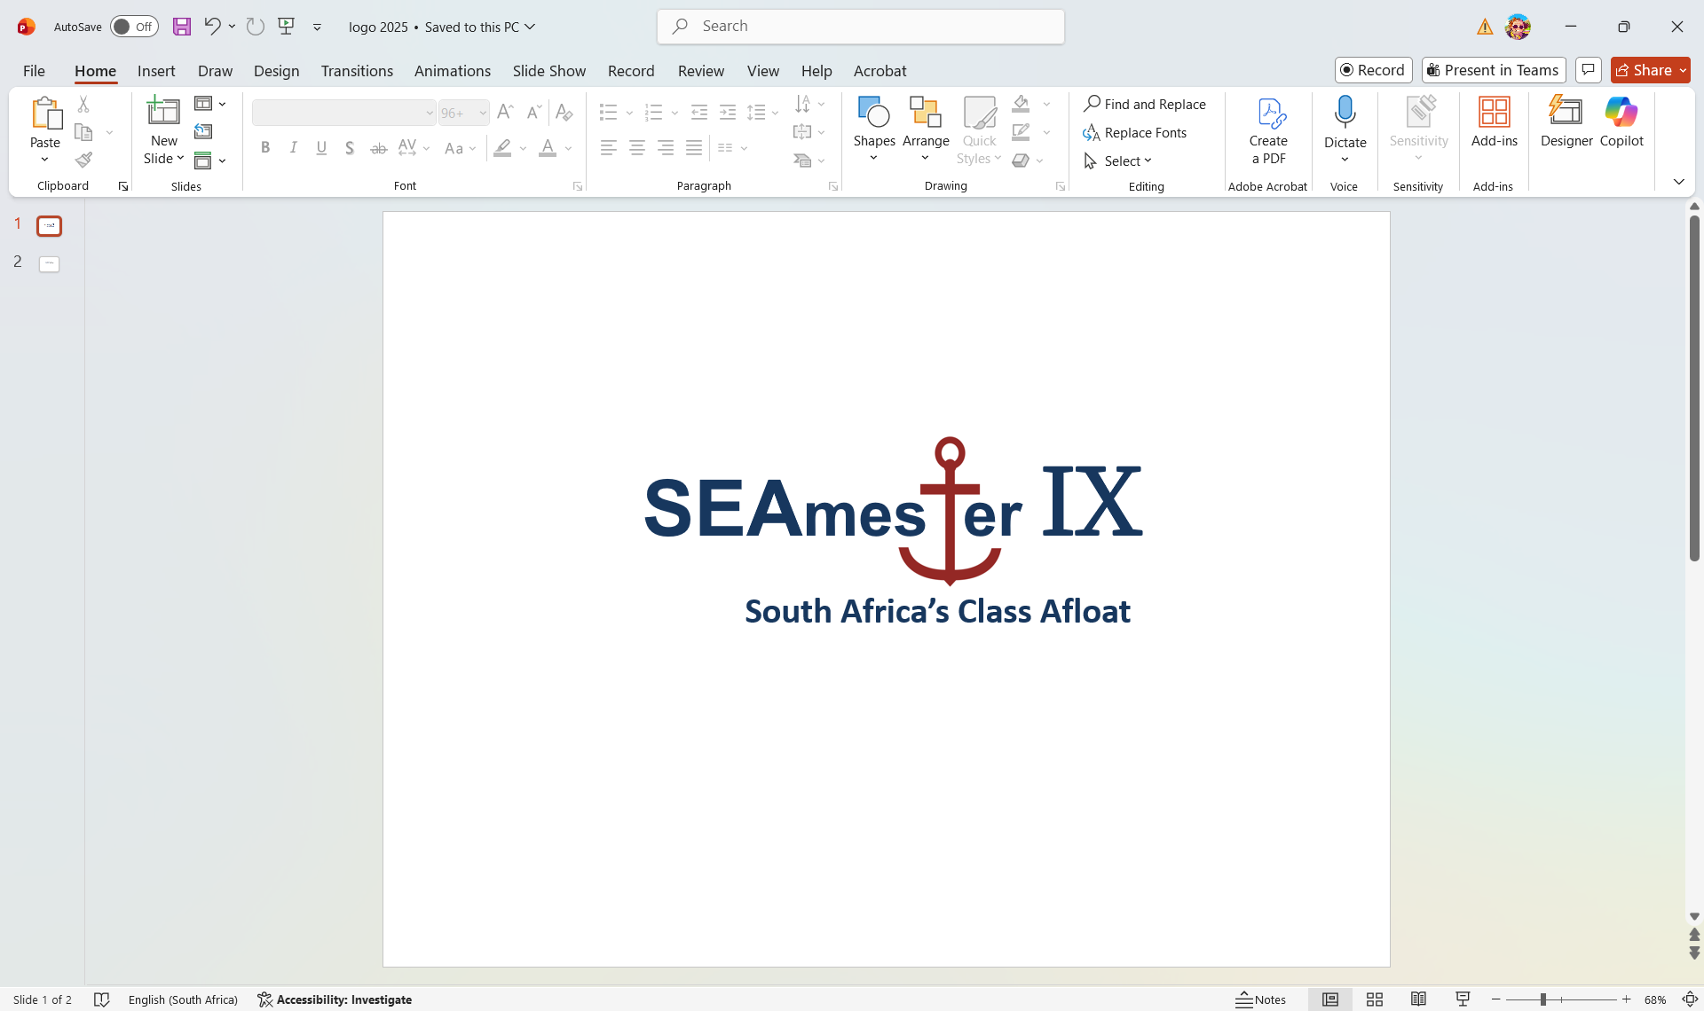

STUDENT APPLICATION FORM
- Please TYPE in your details – no handwritten applications will be accepted
- To be returned to Isabelle.Ansorge@uct.ac.za by Thursday 19th March 2026
- No late applications will be considered
- Please prepare one pdf document and label file (SEAmester and your Name and Institute) i.e. SEAmester-Ansorge–UCT. Please note that multiple files will not be accepted
- Please ensure you have added your 1 min (max) motivation video supporting your application.
SEAmester IX dates 1st to 10th June 2026
SUMMARY INFORMATION
Current University
Current degree i.e. Btech, MSc
Title of your current thesis – if applicable
First Name and Surname
ID Number
Learning Stream of Choice? | - Option 1 – Oceans in a Changing World  - Option 2 - Tools of the Trade  - Either
Have you applied to SEAmester before? | - Yes (accepted/rejected in ________________)  - No  Please note preference will be given to students who have not participated on a SEAmester cruise before.
Please insert into the rectangle a photo of yourself, which (if your application is successful) will be included in the introductory information pack distributed to all SEAmester participants.

A) PERSONAL DETAILS

First Name (as per ID)
Surname (as per ID)
Gender – Please select your gender as it is required for cabin allocations | - Male  - Female
Email address
Cellphone Number
Date of birth
Country of citizenship
Passport number PLEASE NOTE THAT A PASSPORT IS NOT REQUIRED FOR YOUR APPLICATION BUT IF SELECTED YOU WILL NEED A PASSPORT 2 WEEKS BEFORE THE CRUISE DEPARTS (15th May)
Expiry Date
Study/Work Visa – expiry date FOR SADC STUDENTS. PLEASE MAKE SURE THAT ANY VISAS ARE VALID 6 MONTHS AFTER THEB SEAMESTER CRUISE ENDS.
T-shirt size | - S  - M  - L  - XL  - XXL
Airport – PLEASE TICK THE AIRPORT YOU WILL NEED TO FLY FROM. PLEASE NOTE STUDENTS REGISTERED AT CPUT, UWC, UCT AND SUN DO NOT QUALIFY FOR AIR TRANSPORT | - PORT ELIZABETH  - EAST LONDON  - BLOEMFONTEIN  - DURBAN  - OR TAMBO – JOHANNESBURG

Name of contact person in case of any emergency
Relationship
Address
Email
Telephone/Mobile number

B) ACADEMIC DETAILS
Highest qualification achieved | - BSc/Btech  - MSc/Mtech  - PhD  - Intern  - Other _______________________
Current degree | □ BSc/Btech  □ MSc/Mtech  □ PhD  □ Intern  □ Other _______________________
Subject area – what areas of marine research interest you the most?
Supervisor of current degree thesis (if applicable)
Email address of supervisor
Tick preferred teaching stream SEE ATTACHED SEAMESTER DESCRIPTION DOCUMENT FOR BOTH STREAMS TO GET AN IDEA OF THE LECTURE LAYOUT.  PLEASE NOTE - ONCE YOU HAVE BEEN SELECTED YOU WILL NOT BE ABLE TO CHANGE YOUR STREAM. | - Option 1 – Oceans in a Changing World  - Option 2 - Tools of the Trade  - Either
How did you hear about SEAmester? | - Friend/Social media  - HoD/Supervisor  - University/Technikon Newsletter  - SANCOR  - Other _______________________________

C) Previous sea-going experience (max 150 words). It is not compulsory for students to have had previous sea-going experience.

D) Motivation - Please provide a personal statement in the form of a video (1 min max) explaining how you believe this programme will benefit you.

Video submitted
- Yes

E) Short Biography of yourself – no more than 50 WORDS please use below as a template and please feel free to add additional sentences.

My name is ** and I am studying for a ** degree ** at ***. I come from ***. My passion for the marine environment is due to ***. My hobbies include **. During this cruise I wish to learn as much as possible on ***

F) Endorsement from either HoD or Supervisor .

Academic Institute ________________________ Position __________________________

Comment __________________________________________________________________
____________________________________________________________________________________________________________________________________________________

Signature _______________________________ Date _____________________________

F) Email address of HoD or Supervisor (signatory of E above). Your performance report will be emailed directly to this person.

G) Sign and date this application to indicate that you have read and understand the SEAmester programme and verify that all the information contained herein is factually correct.

Signature _______________________________ Date _____________________________

H) SEAmester South Africa’s Class Afloat - Student Declaration

If I am selected, I, the undersigned, acknowledge and accept my responsibilities as a student on the SEAmester Program. I understand that SEAmester upholds a long-standing reputation for excellence in delivering high-quality, intensive, engaging academic content and hands-on training, which is a privilege to be part of.

By signing this declaration, I commit to the following:

  - Attending all meetings, lectures and deck work in my stream and on time.
  - Ensure that I am always suitably dressed for lectures, deck work and most importantly mealtimes.
  - Understand that the mealtimes work on a rotation basis and there is limited seating and time between meals and lectures.
  - Actively participate in all activities throughout the voyage.
  - Dedicate my full time and enthusiasm to the program without distraction i.e. cellphone, cabin mates, social media.
  - Contribute to a productive and focused learning environment both in the classroom and on deck.

I understand that SEAmester is an intensive academic experience, and I pledge to participate in all activities and make the most of this experience for the duration of the voyage.

Signature: _____________________ Date: _____________________

Please prepare one pdf document and label file (SEAmester and your Name and Institute) i.e. SEAmester-Ansorge–UCT. Please ensure that your video clip is attached to your email.

CHECK LIST
Please tick each box to ensure you pdf file contains all the necessary documents

Included
- Application form
- Endorsement from HoD or supervisor
- Email address for your performance report to be sent to
- Proof of registration at current university or technikon
- Recent academic transcript
- Copy of valid passport IF AVAILABLE
- Copy of valid ID
- Photograph of yourself
- Short Biography
- 1 min (max) motivation video
- Signed declaration

Understand
- That you have read all attached documentation and included all the items listed above
- That an incomplete application form will not be considered
- That the final deadline is Thursday 19th March 2026 and no late applications will be considered
- Travel assistance will be provided by SEAmester in the form of return flights and a shuttle from Cape Town Airport to the ship ONLY. You are responsible for your transport to and from the airport in your respective hometown. If you reside in Cape Town, you are responsible for your transport to and from the ship pre and post SEAmester.

