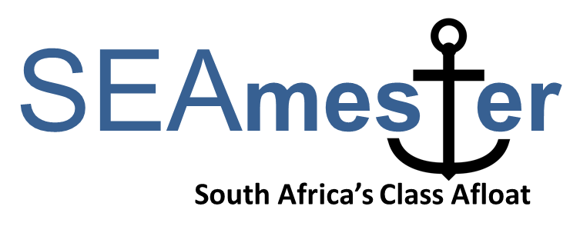

-------------------------------------------------------------------------------------------------
STUDENT APPLICATION FORM – please type in your details
To be returned to Isabelle.Ansorge@uct.ac.za by Friday 22nd April 2022
* No late applications will be considered.
SEAmester V dates are 27th June – 8th July 2022

Current University
Current Degree i.e. Btech, MSc
FULL NAME
ID
Have you applied to SEAmester before  Please note preference will be gven to students who have not particIpated on a SEAmester programme before or were accepted for the 2020 cancelled cruise | - 2016  - 2017  - 2018  - 2019  - Accepted for 2020 SEAmester – you must still be registered as a student  - No
Vaccine QR code (only applicants who are already vaccinated will be considered)
Vaccine Please tick | Pfizer | Single | Double | Booster | J&J

A) Personal details

First name
Last name
Gender |  | - Male  - Female
Email address
Contact Number
Date of birth
Country of citizenship
Passport number PLEASE NOTE THAT A PASSPORT IS NOT REQUIRED FOR YOUR APPLICATION BUT IF SELECTED YOU WILL NEED A PASSPORT IN TIME FOR THE CRUISE
Expiry Date
Study/Work Visa – expiry date FOR SADC STUDENTS. PLEASE MAKE SURE THAT ANY VISAS ARE VALID 6 MONTHS AFTER SEAMESTER ENDS.
South African ID (if available)
Clothing size | - S  - M  - L  - XL  - XXL
Airport – PLEASE TICK THE AIRPORT YOU WILL NEED TO FLY FROM. PLEASE NOTE STUDENTS RESIDING AT CPUT, UWC, UCT AND SUN DO NOT QUALIFY FOR AIR TRANSPORT | - PORT ELIZABETH  - EAST LONDON  - DURBAN  - O R TAMBO – JOHANNESBURG

Name of contact person in case of any emergency
Relationship
Address
Email
Telephone/Mobile number

B) Academic details
Highest qualification achieved | - BSc/Btech  - MSc/Mtech  - PhD  - Intern  - Other _______________________
Current year of study
Current degree | □ BSc/Btech  □ MSc/Mtech  □ PhD  □ Intern  □ Other _______________________
Subject area – what areas of marine research interest you the most?
Title of degree thesis (if applicable)
Supervisor of current degree thesis (if applicable)
Email address of supervisor
Tick preferred teaching stream SEE ATTACHED SEAMESTER DESCRIPTION DOCUMENT FOR BOTH STREAMS TO GET AN IDEA OF THE LECTURE LAYOUT.  PLEASE NOTE - ONCE YOU HAVE BEEN SELECTED YOU WILL NOT BE ABLE TO CHANGE YOUR STREAM. | - Option 1 – Oceans in a Changing World  - Option 2 - Tools of the Trade
How did you hear about SEAmester? | - Friend/Social media  - HoD/Supervisor  - University/Technikon Newsletter  - SANCOR  - Other _______________________________

C) Previous sea-going experience (max 150 words). It is not compulsory for students to have had previous sea-going experience.

D) Motivation - please include how you would benefit from this course (max 250 words).

E) Short Biography of yourself – no more than 50 WORDS please use below as a template and please feel free to add additional sentences. Please include a photo.

My name is ** and I am studying for a ** degree ** at ***. I come from ***. My passion for the marine environment is due to ***. My hobbies include **. During this cruise I wish to learn as much as possible on ***

F) Endorsement from either HoD or Supervisor .

Acdemic Institute ________________________ Position ____________________________

Comment __________________________________________________________________
______________________________________________________________________________________________________________________________________________________

Signature _______________________________ Date ______________________________

F) Email address of HoD or Supervisor (signatory of E above). Your performance report will be emailed directly to this person.

G) Sign and date this application to indicate that you have read and understand the SEAmester programme and verify that all the information contained herein is factually correct.

Signature _______________________________ Date ______________________________

Please prepare one pdf document and label file (SEAmester and your Name and Institute) i.e. SEAmester-Ansorge–UCT.
CHECK LIST
Please tick each box to ensure you pdf file contains all the necessary doucments

Included
- Application form
- Vaccination Certificate (compulsory submission)
- Endorsement from HoD or supervisor
- Email address for your performance report to be sent to
- Proof of registration at current university or technikon
- Recent academic transcript
- Copy of valid passport IF AVAILABLE
- Copy of valid ID
- Photograph of yourself
- Short Biography
- That you understand that COVID restrictions will be applied (72 hour PCR test and Rapid test on day of departure) and also that a posisble 5th wave may result in the cancellation of this voyage

Understand
- That you have read all attached documentation
- That an incomplete application form will not be considered
- That the final deadline is Friday 22nd April 2022 and no late applications will be considered

