SOUTH AFRICAN NETWORK FOR COASTAL AND OCEANIC RESEARCH
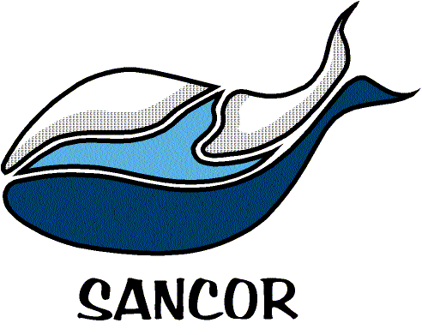

NOMINATION FORM FOR THE
MARINE AND COASTAL COMMUNICATOR OF THE YEAR AWARD 2017
Please submit this form and the nominee’s CV by e-mail to: Sancor@daff.gov.za by 28 February 2017.
Contact Information of Proposer/Nominator
Name
Telephone
Cell phone number
E-mail address
What is your relationship with the nominee?
Details of Nominee for Communicator Award
Name
Telephone
Cell phone number
E-mail address
Award Category:  please highlight accordingly | Professional (journalists, environmental educators, etc.) | Community (volunteers, etc.) | Scientific
Current Employment
Present employer
Job description (brief)
List significant popular talks given, and/or publications and/or resource materials produced, by the nominee during the last 5 years. Where practical, examples of resource materials should accompany the motivation.
Please provide a comprehensive motivation of why you feel that the nominee is a worthy candidate for the award. This motivation should be a maximum of 1500 words. The strength of the motivation generally determines the strength of the candidate.

