SOUTH AFRICAN NETWORK FOR COASTAL AND OCEANIC RESEARCH
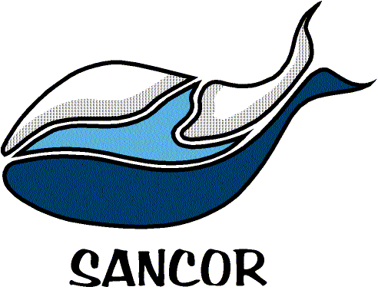

NOMINATION FORM FOR THE DEREK KRIGE MEDAL 2017
Please submit this form and the nominee’s CV by e-mail to: Sancor@daff.gov.za by 28 February 2017.
Contact Information of Proposer/Nominator
Name
Telephone
Cell phone number
E-mail address
What is your relationship with the nominee?
Details of Nominee for the Derek Krige Medal
Full Name and Title
Date of Birth (YY/MM/DD)
Telephone
Cell phone number
E-mail address
Current position and job description
Summarize the nominee’s contribution in the field of technical support to marine science in South Africa. Where relevant, please describe in one paragraph under the following headings (one paragraph per heading):
1. The development and application of techniques, equipment and/or systems by the candidate that represent advances in marine science, marine technology, aquariology or mariculture.
2. The candidate's exceptional and innovative contributions to formal and informal training and/or capacity building of those involved in marine science and technology.
3. The candidate's technical skills and how they have been able to advance significantly excellence in the field of marine science in South Africa.
4. Other
Note any other special attributes that you consider the committee should be aware of and which identity the candidate as being a worthy recipient of this award. These could include personality attributes, obstacles overcome or achievements outside the normal professional measures typically listed in CVs!

