SOUTH AFRICAN NETWORK FOR COASTAL AND OCEANIC RESEARCH
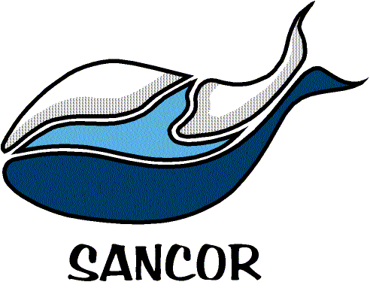

NOMINATION FORM
FOR
SANCOR EMERGING SCIENTIST AWARD 2017
Please submit this form and the nominee’s CV by e-mail to:
sancor@daff.gov.za by 28 February 2017.

This submission should be accompanied by a full curriculum vitae: The candidate’s CV (no longer than 25 pages) should provide a complete listing of personal and professional information, including involvement with supervision of research and awards received, as well as a full list of publications where appropriate.

Contact Information of Proposer
Name:
Telephone:
Mobile:
E-mail address:

Details of Nominee for Young Marine Scientist Award
Name:
Telephone:
Mobile:
E-mail address:
Present employer:
Job description (brief):
Please provide a comprehensive motivation of why you feel that the nominee is a worthy candidate for the award. The strength of the motivation generally determines the strength of the candidate. Describe (where relevant) how the candidate fulfills the criteria for the award.

- Describe how the candidate has shown potential to contribute or already contributed to the advancement of science in the marine and coastal environments (SMCE) in the fields of natural science, social science, management, industry, education, etc.
- How has the nominee illustrated the potential to become a leader and role model within the field of SMCE?
- The candidate should show evidence of national and/or international eminence (e.g. presentation at international conferences and membership in national or international committees that contribute to the advancement of SMCE, etc.). Provide examples of these activities.
- Describe the candidate’s experience in mentoring and guiding young people in SMCE (whether in industry, government, academia, etc.).

