  - 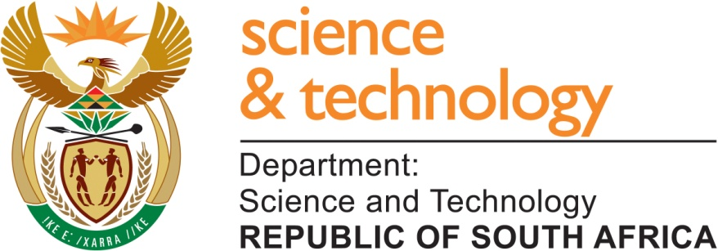

  - Terms of Reference for the development of the South African Marine Research Plan

August 2013

- ASSIGNMENT TITLE
The development of a national marine research plan

- ASSIGNMENT
The Department of Science and Technology (DST) through the National Research Foundation (NRF) undertakes to coordinate a process to develop a single comprehensive national marine research plan. Working groups will be selected to provide theme-specific inputs into a marine research plan that will feed into the overarching Antarctic and Marine Sciences Research Strategy. The marine research plan will focus on the specific marine research needs and strengths of the country that will best position South African research within the global context. This plan will also provide an understanding of the cutting-edge and strategic research interests within the field, as well as outline mechanisms for implementation in the short, medium and long term.

- BACKGROUND
The DST derives its mandate from the 1996 White Paper on Science and Technology. The premise is that science, technology and innovation play a critical role in economic growth and the socio-economic development of South Africa. The DST consequently promotes the development of the National System of Innovation and influences this system via key strategies such as the 2002 National Research and Development (R&D) Strategy and the 2008 Ten-year Innovation Plan for South Africa, Innovation Towards a Knowledge-based Economy 2008-2018. The R&D strategy identifies priority science missions that take advantage of South Africa’s geographic position.

Marine sciences are among these science missions. The geographical orientation of South Africa provides the country with one of the densest, most ecologically diverse and oceanographically complex marine environments in the world. The ten-year Innovation Plan identifies five key Grand Challenges for the National System of Innovation. One of these Grand Challenges is science and technology in response to global change with a focus on climate change, commonly referred to as the Global Change Grand Challenge.

Globally the oceans and seas are essential to sustain life on earth. Marine sciences provide us with essential information and knowledge for nations to be able to make policy decisions that will ultimately impact on the management of the marine environment. There are emergent environmental impacts on the marine that are brought about by human activities, ocean acidification and climate change that are becoming more evident. All this creates needs in the marine environment to consider national imperatives.

The DST recognises the need for well-coordinated support for South African marine research that not only advances science, but would also promote effective management of resources and bring as much benefit to the South African people as possible. Thus, this research plan will prioritise and identify mechanisms to optimise marine research funding using both newly identified and existing instruments.

- THE NEED FOR A MARINE RESEARCH STRATEGY
The NRF has been tasked to facilitate the parallel processes of developing the Antarctic and marine sciences research plans. Because Antarctic and Southern Ocean research activities occur in an international space, and are subject to international agreements and regulations, a separate process will be used to develop a research plan for this research area. From the outset it is apparent that the South African marine environment is a diverse ecological system under immense pressures. In this field, a large number of researchers are involved, and therefore it would require a far larger research effort to be able to understand and optimally use the available marine resource.

The imperative of Government is to ensure that state funds are spent in an optimal manner, which would not only require policy guidelines but also an optimal configuration of current and future efforts and existing players in a common thrust, diverse as its aims may be. These diverse efforts can be guided, though not necessarily controlled, by a well-conceived, commonly agreed strategy that takes into account not only the current state of the marine science establishment, but also the diverse needs of the South African people. Scientific understanding that supports and promotes human and ecosystem well-being, sustainable development of communities, protection and preservation of biodiversity and the proper management of coastal development is the desired goal. The overarching Antarctic and marine research strategy will also be anchored on this imperative for marine sciences development.

A national marine and coastal research plan will enable South Africa to consider its national interests, and then to use international exploration to complement these national imperatives.

- ASSIGNMENT OBJECTIVES
The marine research plan will provide a platform to increase knowledge capital; create links between basic research and applied research; foster a growing mass of local scientists in marine research programmes from institutions that previously were not actively participating; increase public awareness and participation; provide stepped-up human resource development initiatives in order to achieve equitable demographics; and, also provide a platform to elevate South Africa’s scientific disciplines to be comparable with international best practises.

- ASSIGNMENT scope
The marine research plan would support research development by encouraging coordinated multi-disciplinary research and human capital development (HCD). It is recognised that any research endeavour aimed at global leadership needs to be underpinned by appropriate support systems and infrastructure. When there is a need for specialised research infrastructure, unique HCD not included in the overarching strategy, etc., this would also be included in the draft plan. In developing the document, the structural framework for the research plan would ideally include the following:
  - Executive Summary,
  - Introduction,
  - Objectives,
  - Research themes,
  - Research infrastructure
  - Human Capital Requirements
  - Science awareness and engagement
  - Conclusion
The document should amongst others:
  - Reflect on the relevant supporting policy options, currently existing and or required to support the plan; and
  - Outline research themes informed by the country’s strengths, and the competitive advantage. For each theme identify goals for 2, 5, and 10 years, existing capacity and opportunities, challenges and gaps, policy drivers and research questions, interventions or proposals. Each theme will have a strategic objective, and outline existing capacity and opportunities, challenges and gaps, policy drivers and research questions, scientific interventions or proposals.

The departure point for the multi-disciplinary marine science research plan can be directed (but not restricted) by the following three themes:
  - Marine Science and Biodiversity initiatives could for example: aim at understanding and predicting the impacts of human activities on biodiversity and the value of biodiversity to human well-being and development. Coordination of marine research projects to address ‘biodiversity’ problems will support this;
  - Marine Science and Society and Development - should seek to research and initiate sustainable development initiatives for poor coastal communities in the coasts that strive to reap full benefits from their immediate marine resources. An understanding of the changes in science, development planning and technology will advance marine science research in the public interest; and
  - Marine Science and Ecosystems – An emphasis should move from exploration and observation in ecosystems research to science. This requires investment in technology inputs and instrumentations for analysing data, and human capacity for scientific analysis to improve scientific impact. Research on key issues of (i) coastal erosion, (ii) management of key ecosystems and habitats, (iii) pollution, and (iv) sustainable use of living resources, and (v) tourism is needed.

- Modalities and Time Frames
The process for the development of the strategy will consist of three tiers of reporting: the Task Team (consisting of NRF/DST officials as well as the lead writer); the lead writer/facilitator will consolidate the inputs from the working groups; and the working groups will develop working documents on the respective themes. These will be coordinated by working group writers. The process will be undertaken in the following six phases:
  - Pre-planning: the DST and NRF will identify and select an appropriate lead writer for the consolidated marine research plan. The milestone for this stage will be a consultative workshop;
  - Project initiation: consultative workshop participants will select theme-specific working group members. After the workshop. working groups will engage separately on various occasions, and will provide inputs to their theme-specific draft document. These inputs will be consolidated into a single theme-specific draft document by the working group writer;
  - Draft consolidation: the working group documents will be consolidated into a comprehensive draft research plan by the lead writer, and will be submitted to the NRF;
  - NRF approval: the NRF will undertake its own internal approval processes and submit the final approved draft document to the DST;
  - DST approval: the DST will refine the document and undertake internal review; and
  - The final stage: final editing and refinement of the document and presentation to the community.

The drafting process will be completed within the 2013/14 financial year as follows:
Year 2013 Early September Establishment of working groups
September Working groups inputs
November consolidation of working group inputs
December refinement of the document

Year 2013 January Document processing
February Amendments
March Document processing

- DISCLAIMER
The Assignment Principal reserves the right to amend the terms of reference in consultation with the Department of Science and Technology should the need arise

